

Project Name: Fitness Tracker

Branch PG-DAC March-2023

Documentation On

**“Fitness Tracker”**

PG-DAC March 2023

**Guided By: Bakul Joshi**

**Submitted By:**

Group No: 01

* **Ritesh Bolane 230343020078**
* **Pratik Khadse 230343020045**
* **Neha Hiray 230343020037**
* **Utkarsha Vinkare 2030343020107**

**Table of Contents**

|  |  |  |
| --- | --- | --- |
| **Sr. No.** | **Title** | **Page No.** |
| **1** | **Introduction** | 1 |
| 1.1 | Document Purpose | 1 |
| 1.2 | Project Background | 1 |
| 1.3 | Aim & Objectives | 1 |
| **2** | **Business Requirements Overview** | 2 |
| **3** | **Functional Requirement Overview** | 3 |
| 3.1 | Trainer Module | 3 |
| 3.2 | Member Module | 3 |
| 3.3 | Admin Module | 3 |
| **4** | **Non-Functional Requirement** | 4 |
| **5** | **Use-Case Diagram** | 5 |
| 5.1 | Admin | 5 |
| 5.2 | Trainer | 6 |
| 5.3 | Member | 7 |
| **6** | **Database Design** | 8 |
| 6.1 | Login Table | 8 |
| 6.2 | User Type | 8 |
| 6.3 | Trainer | 8 |
| 6.4 | Slot | 9 |
| 6.5 | Membership | 9 |
| 6.6 | Meal Type | 9 |
| 6.7 | Goal | 9 |
| 6.8 | Exercise Table | 10 |
| 6.9 | Dietitian Table | 10 |
| 6.10 | Diet Table | 10 |
| 6.11 | Workout Table | 11 |
| 6.12 | Member Table | 11 |
| 6.13 | Tracking Tabel | 12 |
| 6.14 | Schedule Table | 12 |
| 6.15 | Payment Table | 12 |
| **7** | **ER-Diagram** | 13 |
| **8** | **Data Flow Diagram** | 14 |
| **9** | **Snapshots** | 15 |

1. **Introduction:**
   1. **Document Purpose:**

This document communicates the business requirements and scope for developing

Fitness Tracker. The scope of this document is to define the functional and non functional requirements, business rules and other constraints requirements.

## Project Background:

The Fitness Tracker project aims to develop a comprehensive fitness monitoring system that caters to the needs of gym administrators, trainers, and members. With the increasing demand for health and wellness services, there is a growing need for effective tools that can help individuals track their fitness progress, set goals, and stay motivated.

## Aim & Objectives:

# The main objective of this system is building a website which improves user accessibility and The main objective of this project is to develop a web-based application that serves as a personal fitness tracker for individuals. The application should allow users to track their activities, set fitness goals, monitor progress, and provide personalized fitness plans and recommendations.

1. **Business Requirements Overview:**

# Fitness Tracker System is a public web application.

# • Users will be able to set personalized fitness goals and monitor their progress towards achieving those goals.

# • The application will provide a library of exercise routines, workout plans, and video tutorials for users to follow.

# • Personal trainers and fitness coaches will have the ability to create and share customized fitness plans with their clients.

# Functional Requirements Overview:

Fitness tracker System consists of three modules described as below.

1. Trainer Module
2. Member Module
3. Admin Module

# **3.1 Trainer** **Module**

# • Personal trainers and fitness coaches will have access to a separate module where they can create and share customized fitness plans with their clients.

# • Trainers can track their clients' progress, provide feedback, and adjust plans accordingly.

# **Member Module**

* Member can buy the membership and start working out
* Member can track the progress through workouts

# **3.3 Admin Module**

* The admin module allows administrator to create, modify, and delete user accounts within the fitness tracker system.

# • Admin can add dieticians and trainers after verifying them.

# • Admin can terminate memberships of gym members.

1. **Non-Functional Requirement:**

# The web application should have an intuitive and user-friendly interface, with a visually appealing design and easy navigation.

# The system should be able to handle many concurrent users and provide a responsive and smooth user experience.

# Users' data should be securely stored and protected, following standard security practices.

# The application should be compatible with a wide range of browsers.

# Performance metrics, such as response time and system uptime, should meet or exceed industry standards.

## 5. Use-Case Diagram

**5.1 Admin:**

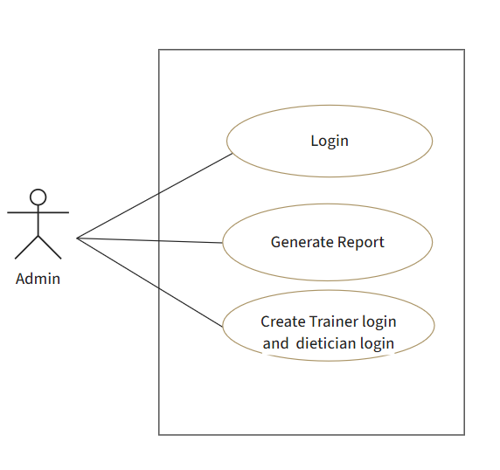

Fig. Use-Case Diagram for Admin

## 5.2 Trainer:

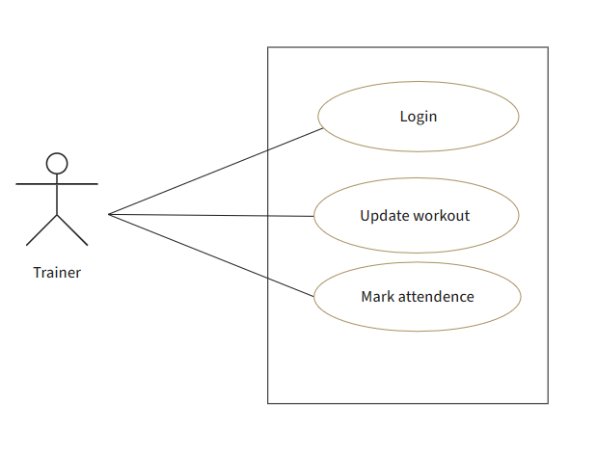

Fig. Use-Case Diagram for Tourist

**5.3 Member:**  
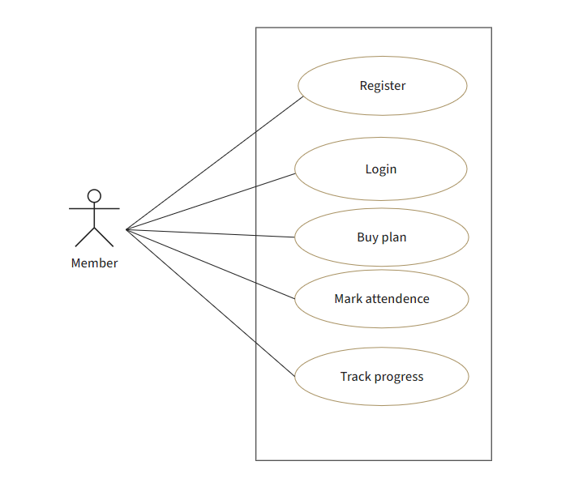

Fig. Use-Case Diagram for Employee

**6. Database Design:**

1. **login table**

|  |  |  |  |  |  |
| --- | --- | --- | --- | --- | --- |
| **login** | | | | | |
| Field | Type | Null | Key | Default | Extra |
|
| id | int | NO | PRI |  | auto_increment |
| Usertype_id | int | NO | FK | NULL | usertype (PK) |
| uid | varchar(45) | YES |  | NULL |  |
| pwd | varchar(45) | YES |  | NULL |  |
| email | varchar(45) | YES |  | NULL |  |
| status | int | No |  | NULL |  |

**2] usertype**

|  |  |  |  |  |  |
| --- | --- | --- | --- | --- | --- |
| **usertype** | | | | | |
| Field | Type | Null | Key | Default | Extra |
|
| id | int | NO | PRI |  | auto_increment |
| name | varchar(45) | NO |  | NULL |  |

**3] trainer**

|  |  |  |  |  |  |
| --- | --- | --- | --- | --- | --- |
| **trainer** | | | | | |
| Field | Type | Null | Key | Default | Extra |
|
| id | int | NO | PRI |  | auto_increment |
| fname | varchar(45) | NO |  | NULL |  |
| lname | varchar(45) | YES |  | NULL |  |
| Login_id | int | YES | FK | NULL | login(PK) |
| email | Varchar(45) | YES |  | NULL |  |
| contact | varchar(45) | YES |  | NULL |  |
| address | Varchar(45) | YES |  | NULL |  |
| experience | int | YES |  | NULL |  |

**4] slot**

|  |  |  |  |  |  |
| --- | --- | --- | --- | --- | --- |
| **slot** | | | | | |
| Field | Type | Null | Key | Default | Extra |
|
| id | int | NO | PRI |  | auto_increment |
| time | Time | NO |  | NULL |  |

**5] membership**

|  |  |  |  |  |  |
| --- | --- | --- | --- | --- | --- |
| **membership** | | | | | |
| Field | Type | Null | Key | Default | Extra |
|
| id | int | NO | PRI |  | auto_increment |
| name | varchar(45) | YES |  | NULL |  |
| baseprice | double | NO |  | NULL |  |
| duration | float | NO |  | NULL |  |

**6] mealtype**

|  |  |  |  |  |  |
| --- | --- | --- | --- | --- | --- |
| **mealtype** | | | | | |
| Field | Type | Null | Key | Default | Extra |
|
| id | int | NO | PRI |  | auto_increment |
| name | Varchar(45) | NO |  | NULL |  |

**7] goal**

|  |  |  |  |  |  |
| --- | --- | --- | --- | --- | --- |
| **goal** | | | | | |
| Field | Type | Null | Key | Default | Extra |
|
| id | int | NO | PRI |  | auto_increment |
| name | Varchar(45) | No |  | NULL |  |

**8] exercise table**

|  |  |  |  |  |  |
| --- | --- | --- | --- | --- | --- |
| **exercise** | | | | | |
| Field | Type | Null | Key | Default | Extra |
|
| id | int | NO | PRI |  | auto_increment |
| name | Varchar(45) | NO |  | NULL |  |
| reps | int | NO |  | 10 |  |
| equipment | varchar(255) | No |  | NULL |  |
| description | Varchar( 255) | NO |  | NULL |  |

**9] dietitian table**

|  |  |  |  |  |  |
| --- | --- | --- | --- | --- | --- |
| **dietitian** | | | | | |
| Field | Type | Null | Key | Default | Extra |
|
| id | int | NO | PRI |  | auto_increment |
| Login_id | int | NO | FK |  | login(PK) |
| fname | Varchar(45) | NO |  | NULL |  |
| lname | Varchar(45) | NO |  | NULL |  |
| email | Varchar(45) | NO |  | NULL |  |
| contact | Varchar(45) | NO |  | NULL |  |
| address | Varchar(45) | NO |  | NULL |  |
| experience | int | NO |  | NULL |  |

**10] diet table**

|  |  |  |  |  |  |
| --- | --- | --- | --- | --- | --- |
| **diet** | | | | | |
| Field | Type | Null | Key | Default | Extra |
|
| id | int | NO | PRI |  | auto_increment |
| Mealtype_id | int | NO |  | NULL |  |
| goal_id | int | NO |  |  |  |
| description | Varchar(1000) |  |  |  |  |

**11] workout table**

|  |  |  |  |  |  |
| --- | --- | --- | --- | --- | --- |
| **workout** | | | | | |
| Field | Type | Null | Key | Default | Extra |
|
| id | int | NO | PRI |  | auto_increment |
| goal_id | int | NO |  |  |  |
| exercise_id | int | NO |  |  |  |
| reps | int |  |  | NULL |  |
| calories | double |  |  | NULL |  |

**12] member table**

|  |  |  |  |  |  |
| --- | --- | --- | --- | --- | --- |
| **member** | | | | | |
| Field | Type | Null | Key | Default | Extra |
|
| id | int | NO | PRI |  | auto_increment |
| fname | Varchar(45) |  |  |  |  |
| lname | Varchar(45) |  |  | NULL |  |
| email | Varchar(45) |  |  | NULL |  |
| Login_id | int | NO | FK |  | Login(PK) |
| bloodgroup | Varchar(45) |  |  | NULL |  |
| height | Varchar(45) |  |  | NULL |  |
| weight | Varchar(45) |  |  | NULL |  |
| contact | Varchar(45) |  |  | NULL |  |
| address | Varchar(45) |  |  | NULL |  |
| goal_id | int | NO | FK |  | goal(PK) |
| status | int |  |  | NULL |  |
| trainer_id | int |  | FK | NULL | trainer(PK) |
| dietitian_id | int |  | FK | NULL | dietitian(PK) |
| membership_id | int |  | FK | NULL | membership(PK) |
| startdate | DateTime(6) |  |  | NULL |  |
| enddate | DateTime(6) |  |  | NULL |  |

**13] tracking table**

|  |  |  |  |  |  |
| --- | --- | --- | --- | --- | --- |
| **tracking** | | | | | |
| Field | Type | Null | Key | Default | Extra |
|
| id | int | NO | PRI |  | auto_increment |
| member_id | int | NO |  |  |  |
| date | Date | NO |  |  |  |
| workout_id | int | NO |  |  |  |
| status | int |  |  |  |  |

**14] schedule table**

|  |  |  |  |  |  |
| --- | --- | --- | --- | --- | --- |
| **schedule** | | | | | |
| Field | Type | Null | Key | Default | Extra |
|
| id | int | NO | PRI |  | auto_increment |
| trainer_id | int | NO |  |  |  |
| shift | int |  |  | NULL |  |
| slot_id | int |  |  | NULL |  |
| member_id | int |  |  | NULL |  |
| status | int |  |  | NULL |  |

**15] payment table**

|  |  |  |  |  |  |
| --- | --- | --- | --- | --- | --- |
| **payment** | | | | | |
| Field | Type | Null | Key | Default | Extra |
|
| id | int | NO | PRI |  | auto_increment |
| member_id | int | NO |  |  |  |
| membership_id | int |  |  |  |  |
| date | DATETIME | NO |  | CURRENT_TIMTSTAMP |  |
| ammount | double |  |  |  |  |

## ER-Diagram:

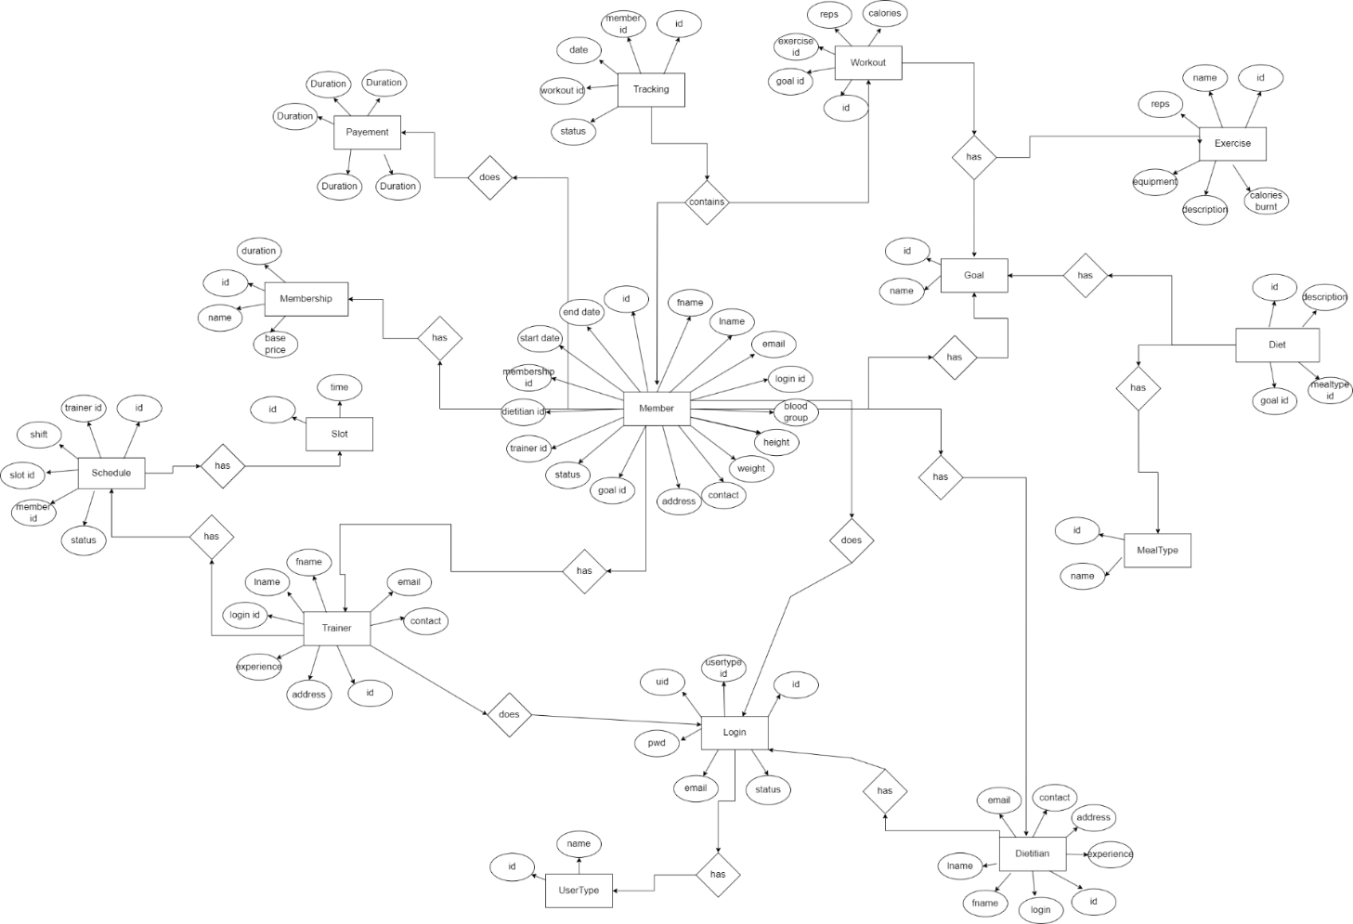

E-R diagram shows database of Fitness Tracker

**8. Snapshots:**

**8.1 Home Page:**

Following snapshot shows the home page for Fitness Tracker before Login.

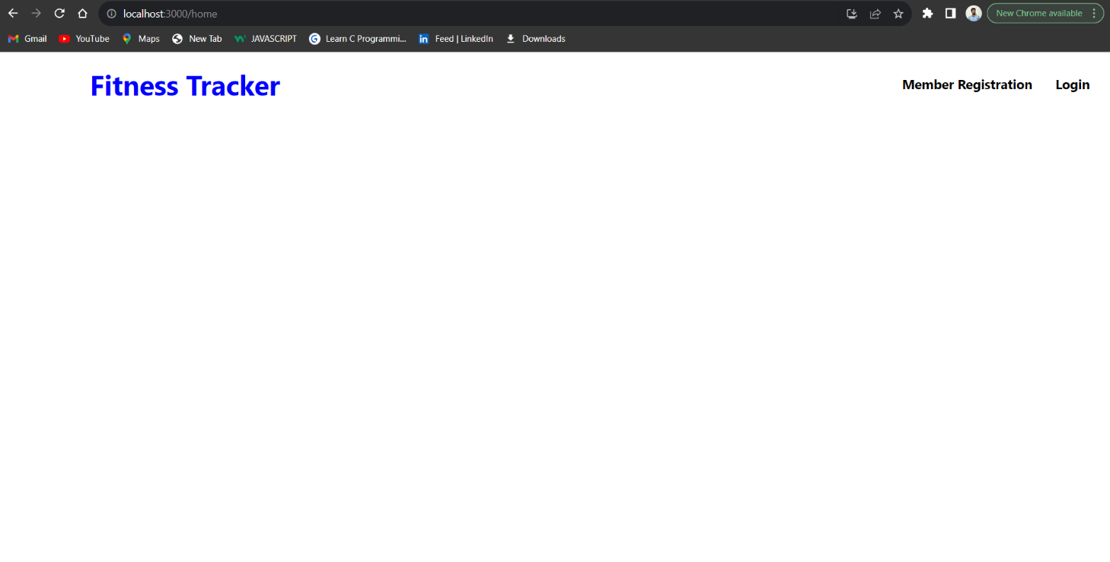

**Member Registration**

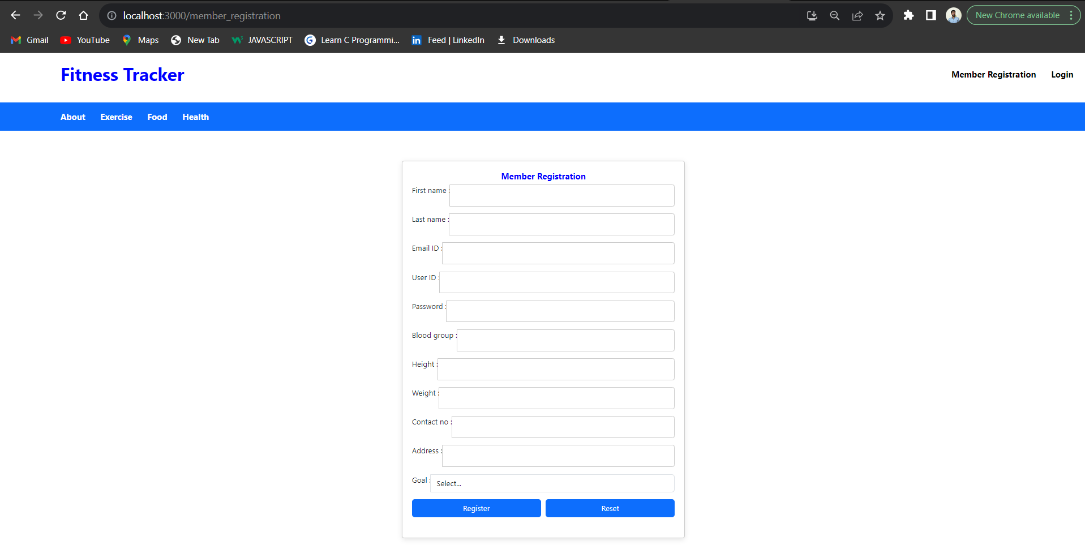

This page contains following controls

* Home
* Sign Up
* Login Button

**8.2 Login Page**

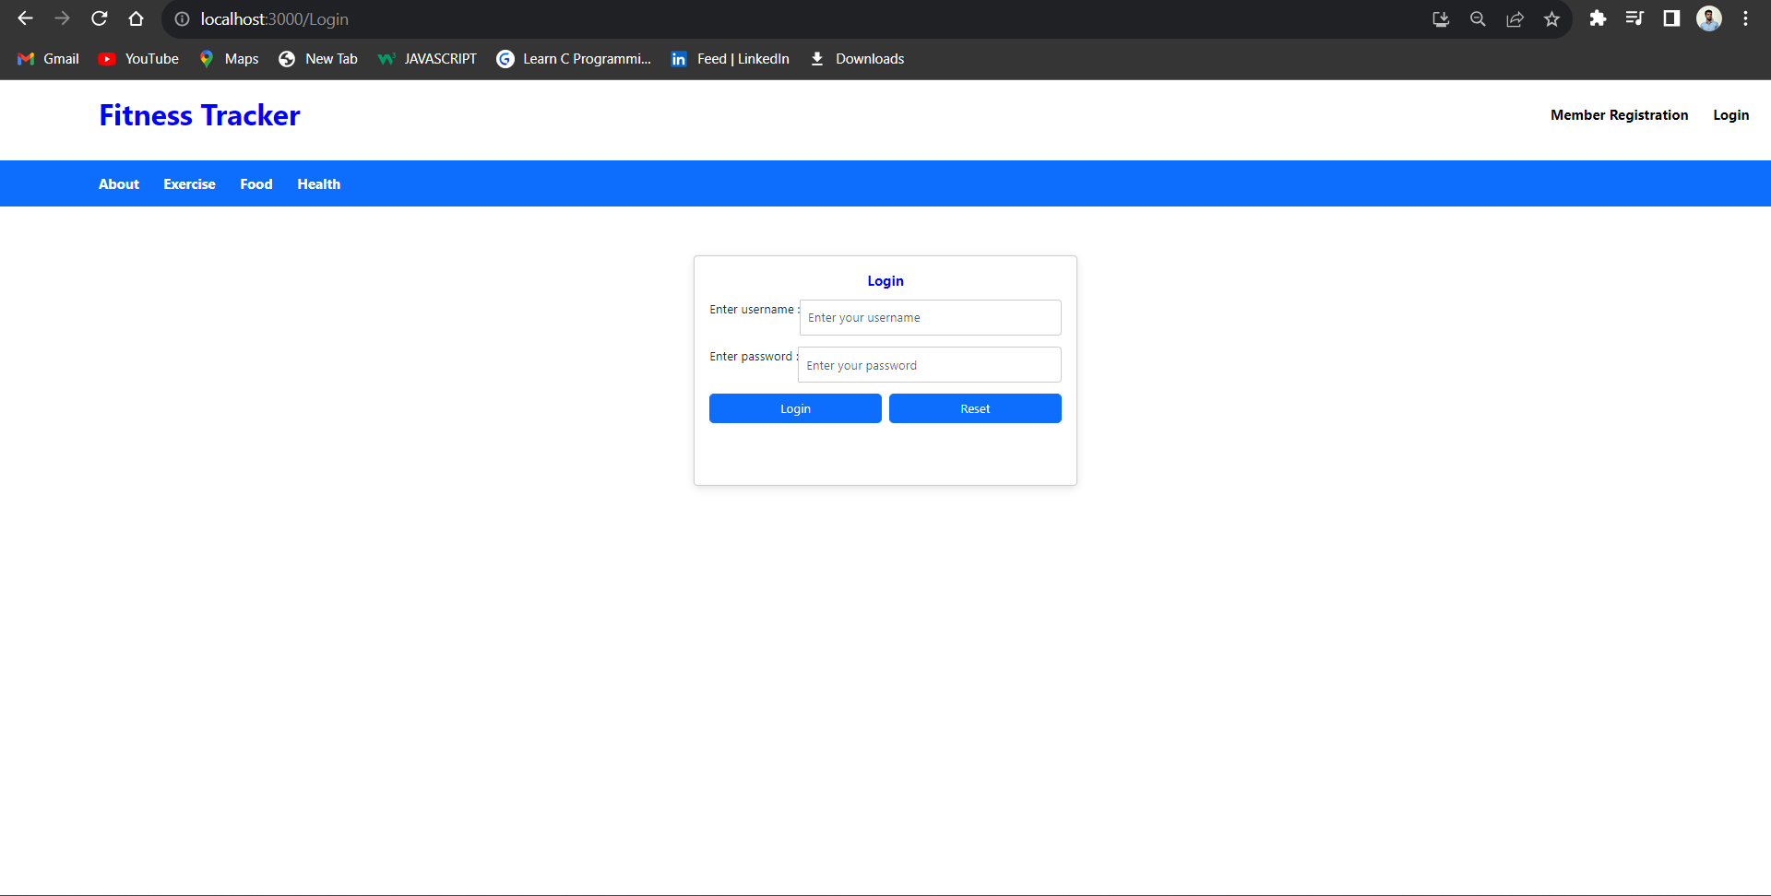

**8.4 Admin Home Page**

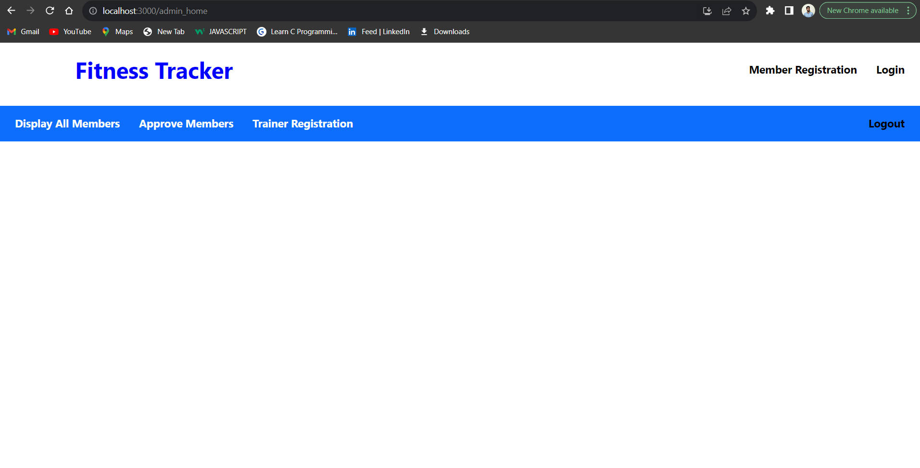

**8.4.1 Display All Members**

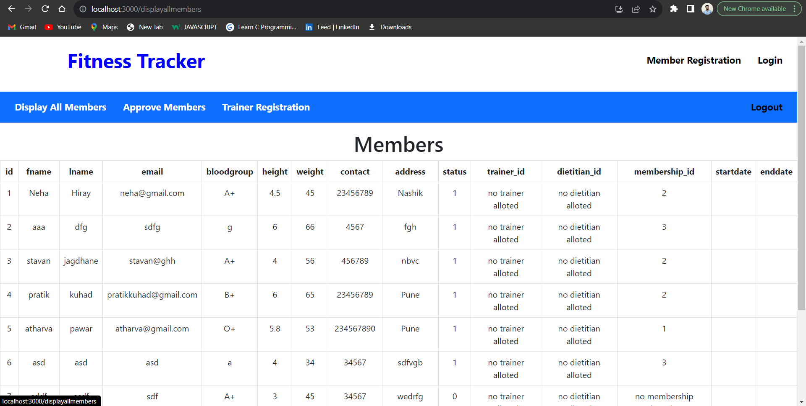

**8.4.2 Trainer Registration**

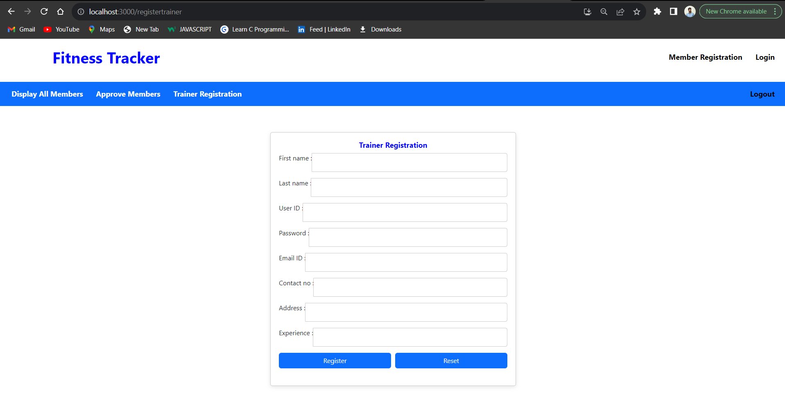

**8.4.3 Approve Member**

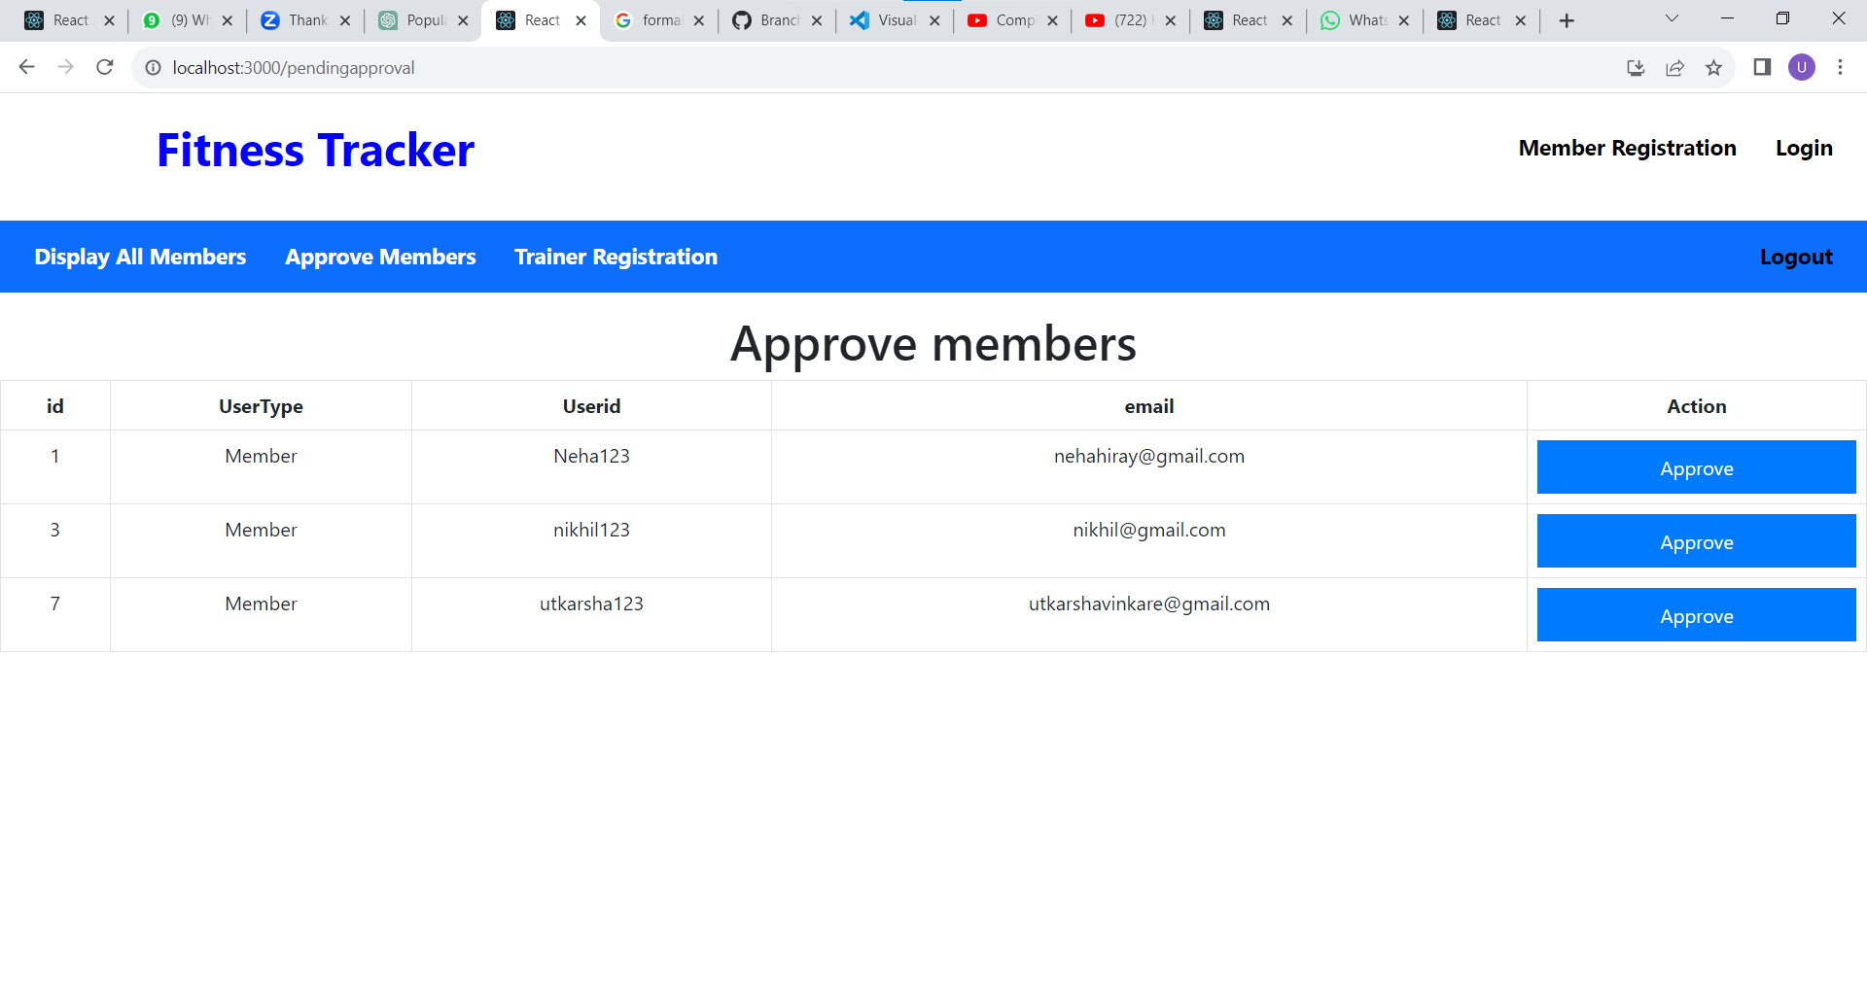

**8.5 Member Home Page**

**8.5.1 Home**

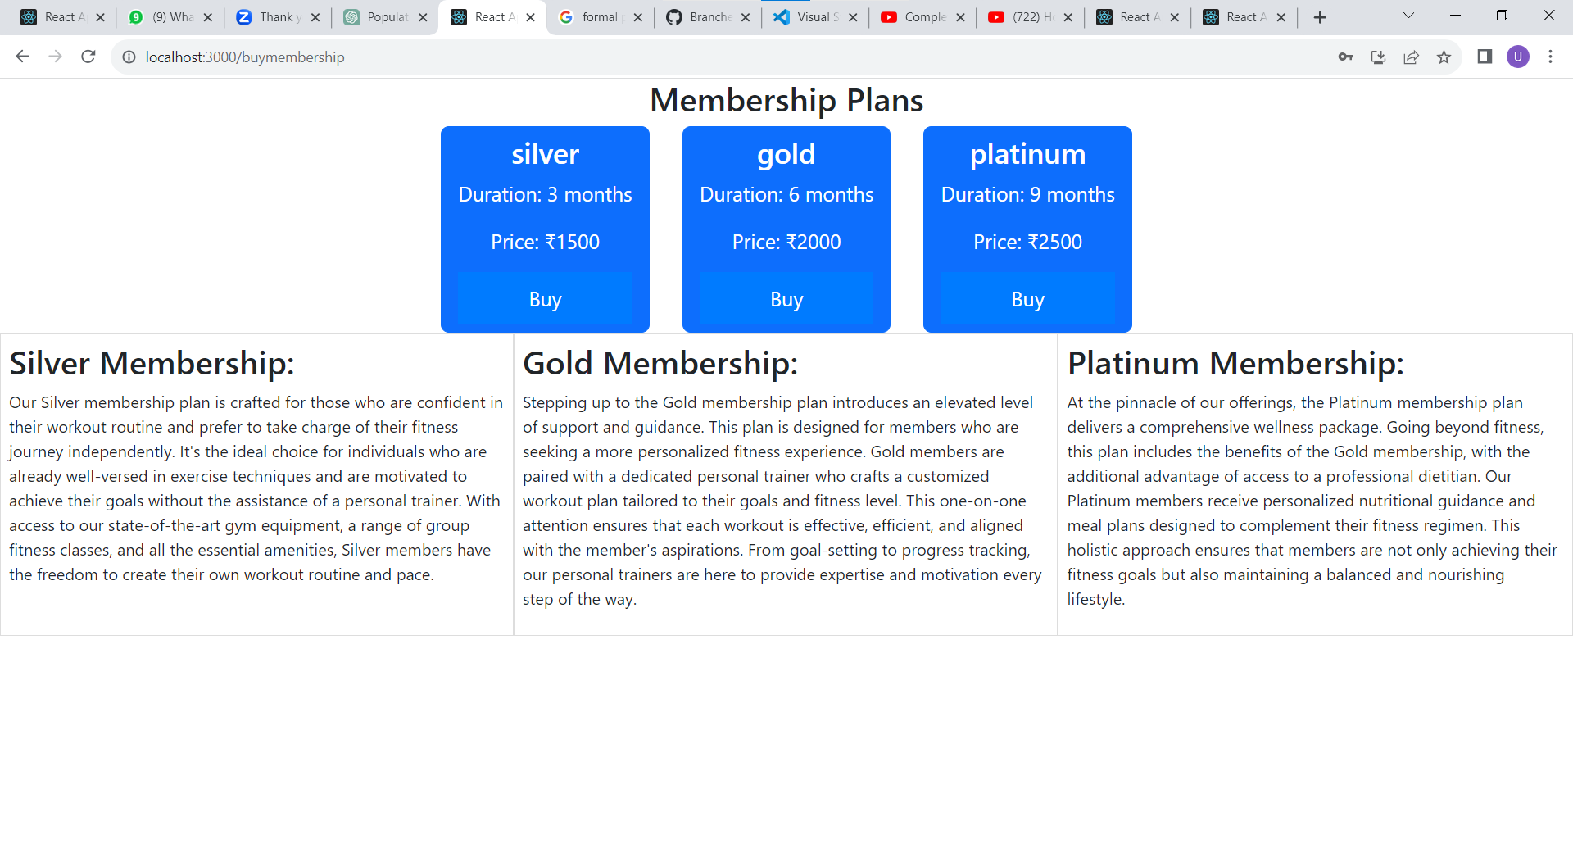

**8.6 Trainer**

**8.6.1 Trainer Home**

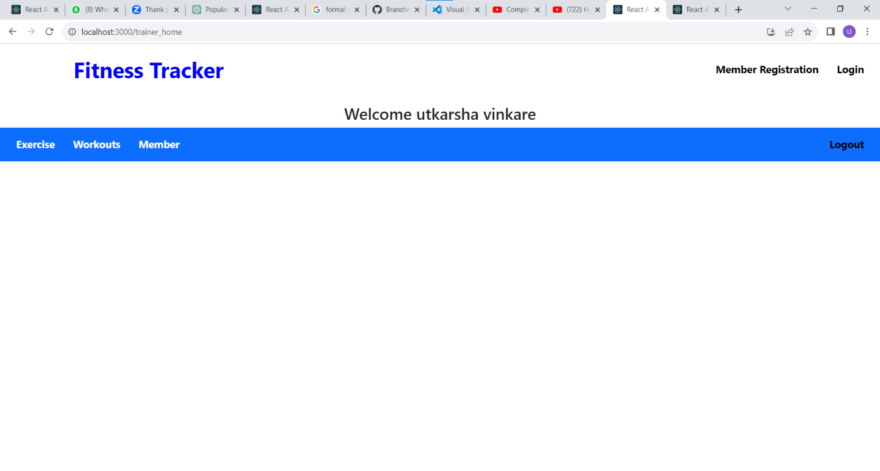**8.6.2 Assign Trainer**

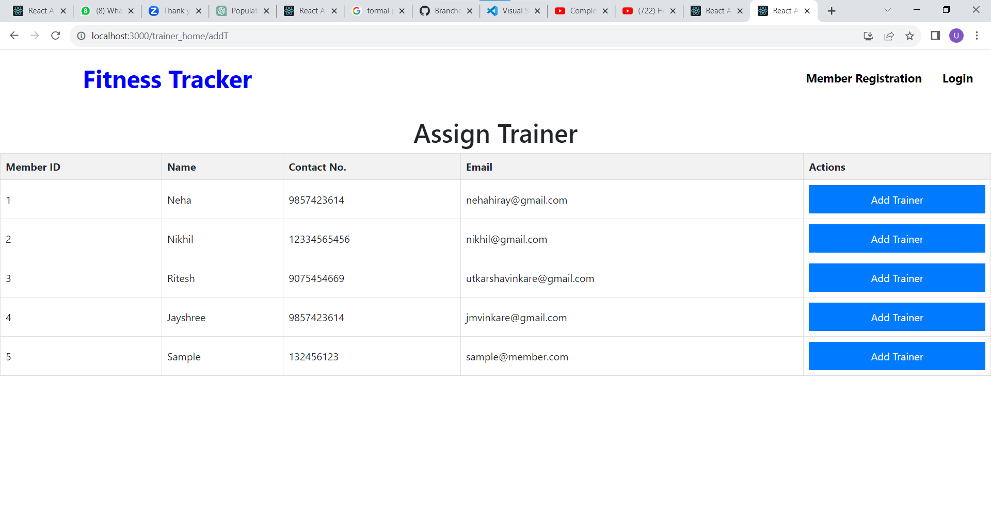

**8.6.3 Add Workout**

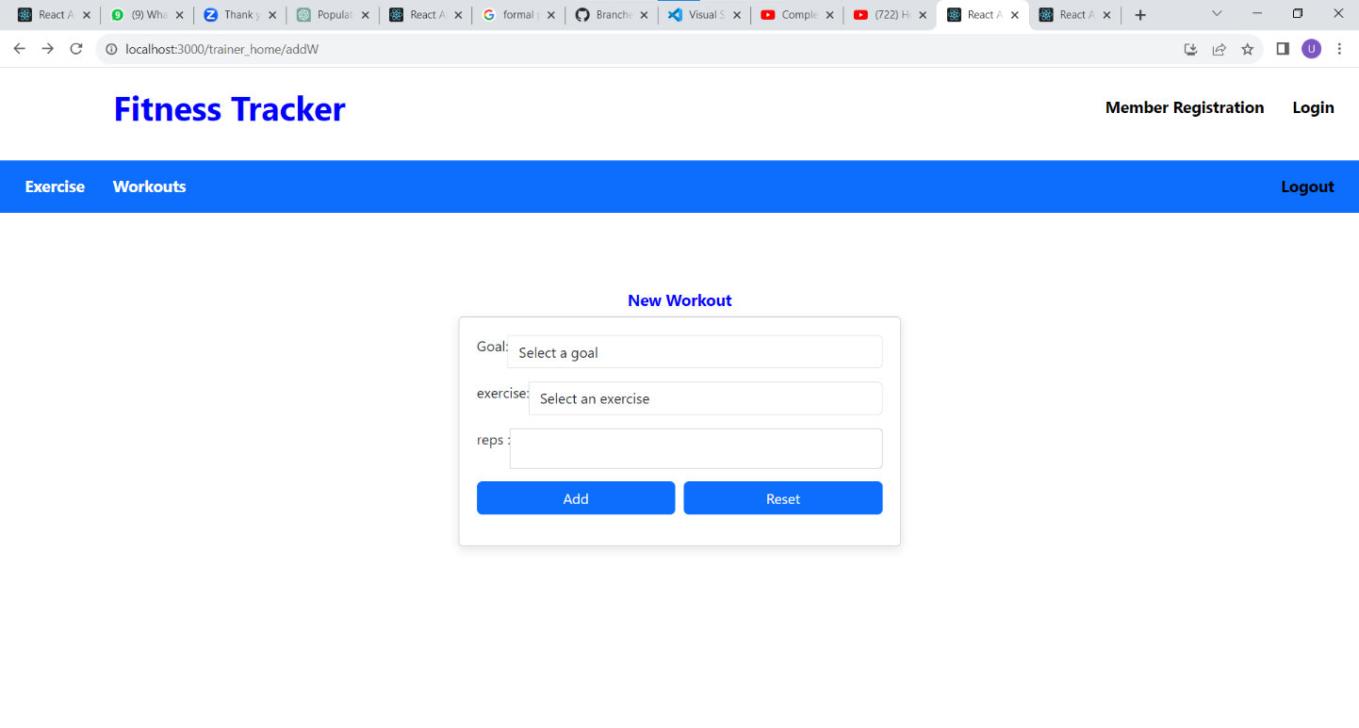

**8.6.4 View Exercises**

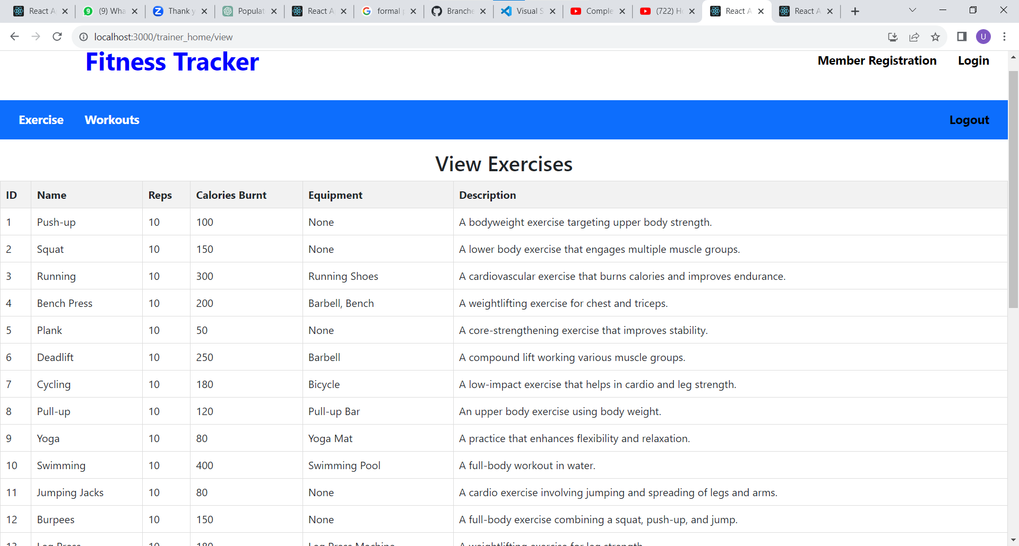

**9. CONCLUSION**

In wrapping up our fitness tracker project, we've accomplished some great things and learned important lessons along the way. Our fitness tracker can keep track of calories burned , weight . It's all about helping people get healthier.